Questions
Are these all the plots we want?

EQRM plotting requirements

plot_api function name | Priority | Done
scenario hazard | 1
hazard with continuous scale | 2 | y
Hazard at locations and return periods | 3 | y
hazard exceedance curve | 4 | y
scen_loss_stats | 5
scen_loss_stats_percentage | 5
scenario % loss map | 6
annloss_deagg_structural | 7
annloss | 8
fig hazard |  | y
loss exceedance |  | y
annloss_deagg_dismag |  | y
annloss_deagg_cells |  | y
probabilistic SA histogram |  | y

What has been done

Fig_hazard
The simulation must be probabilistic.

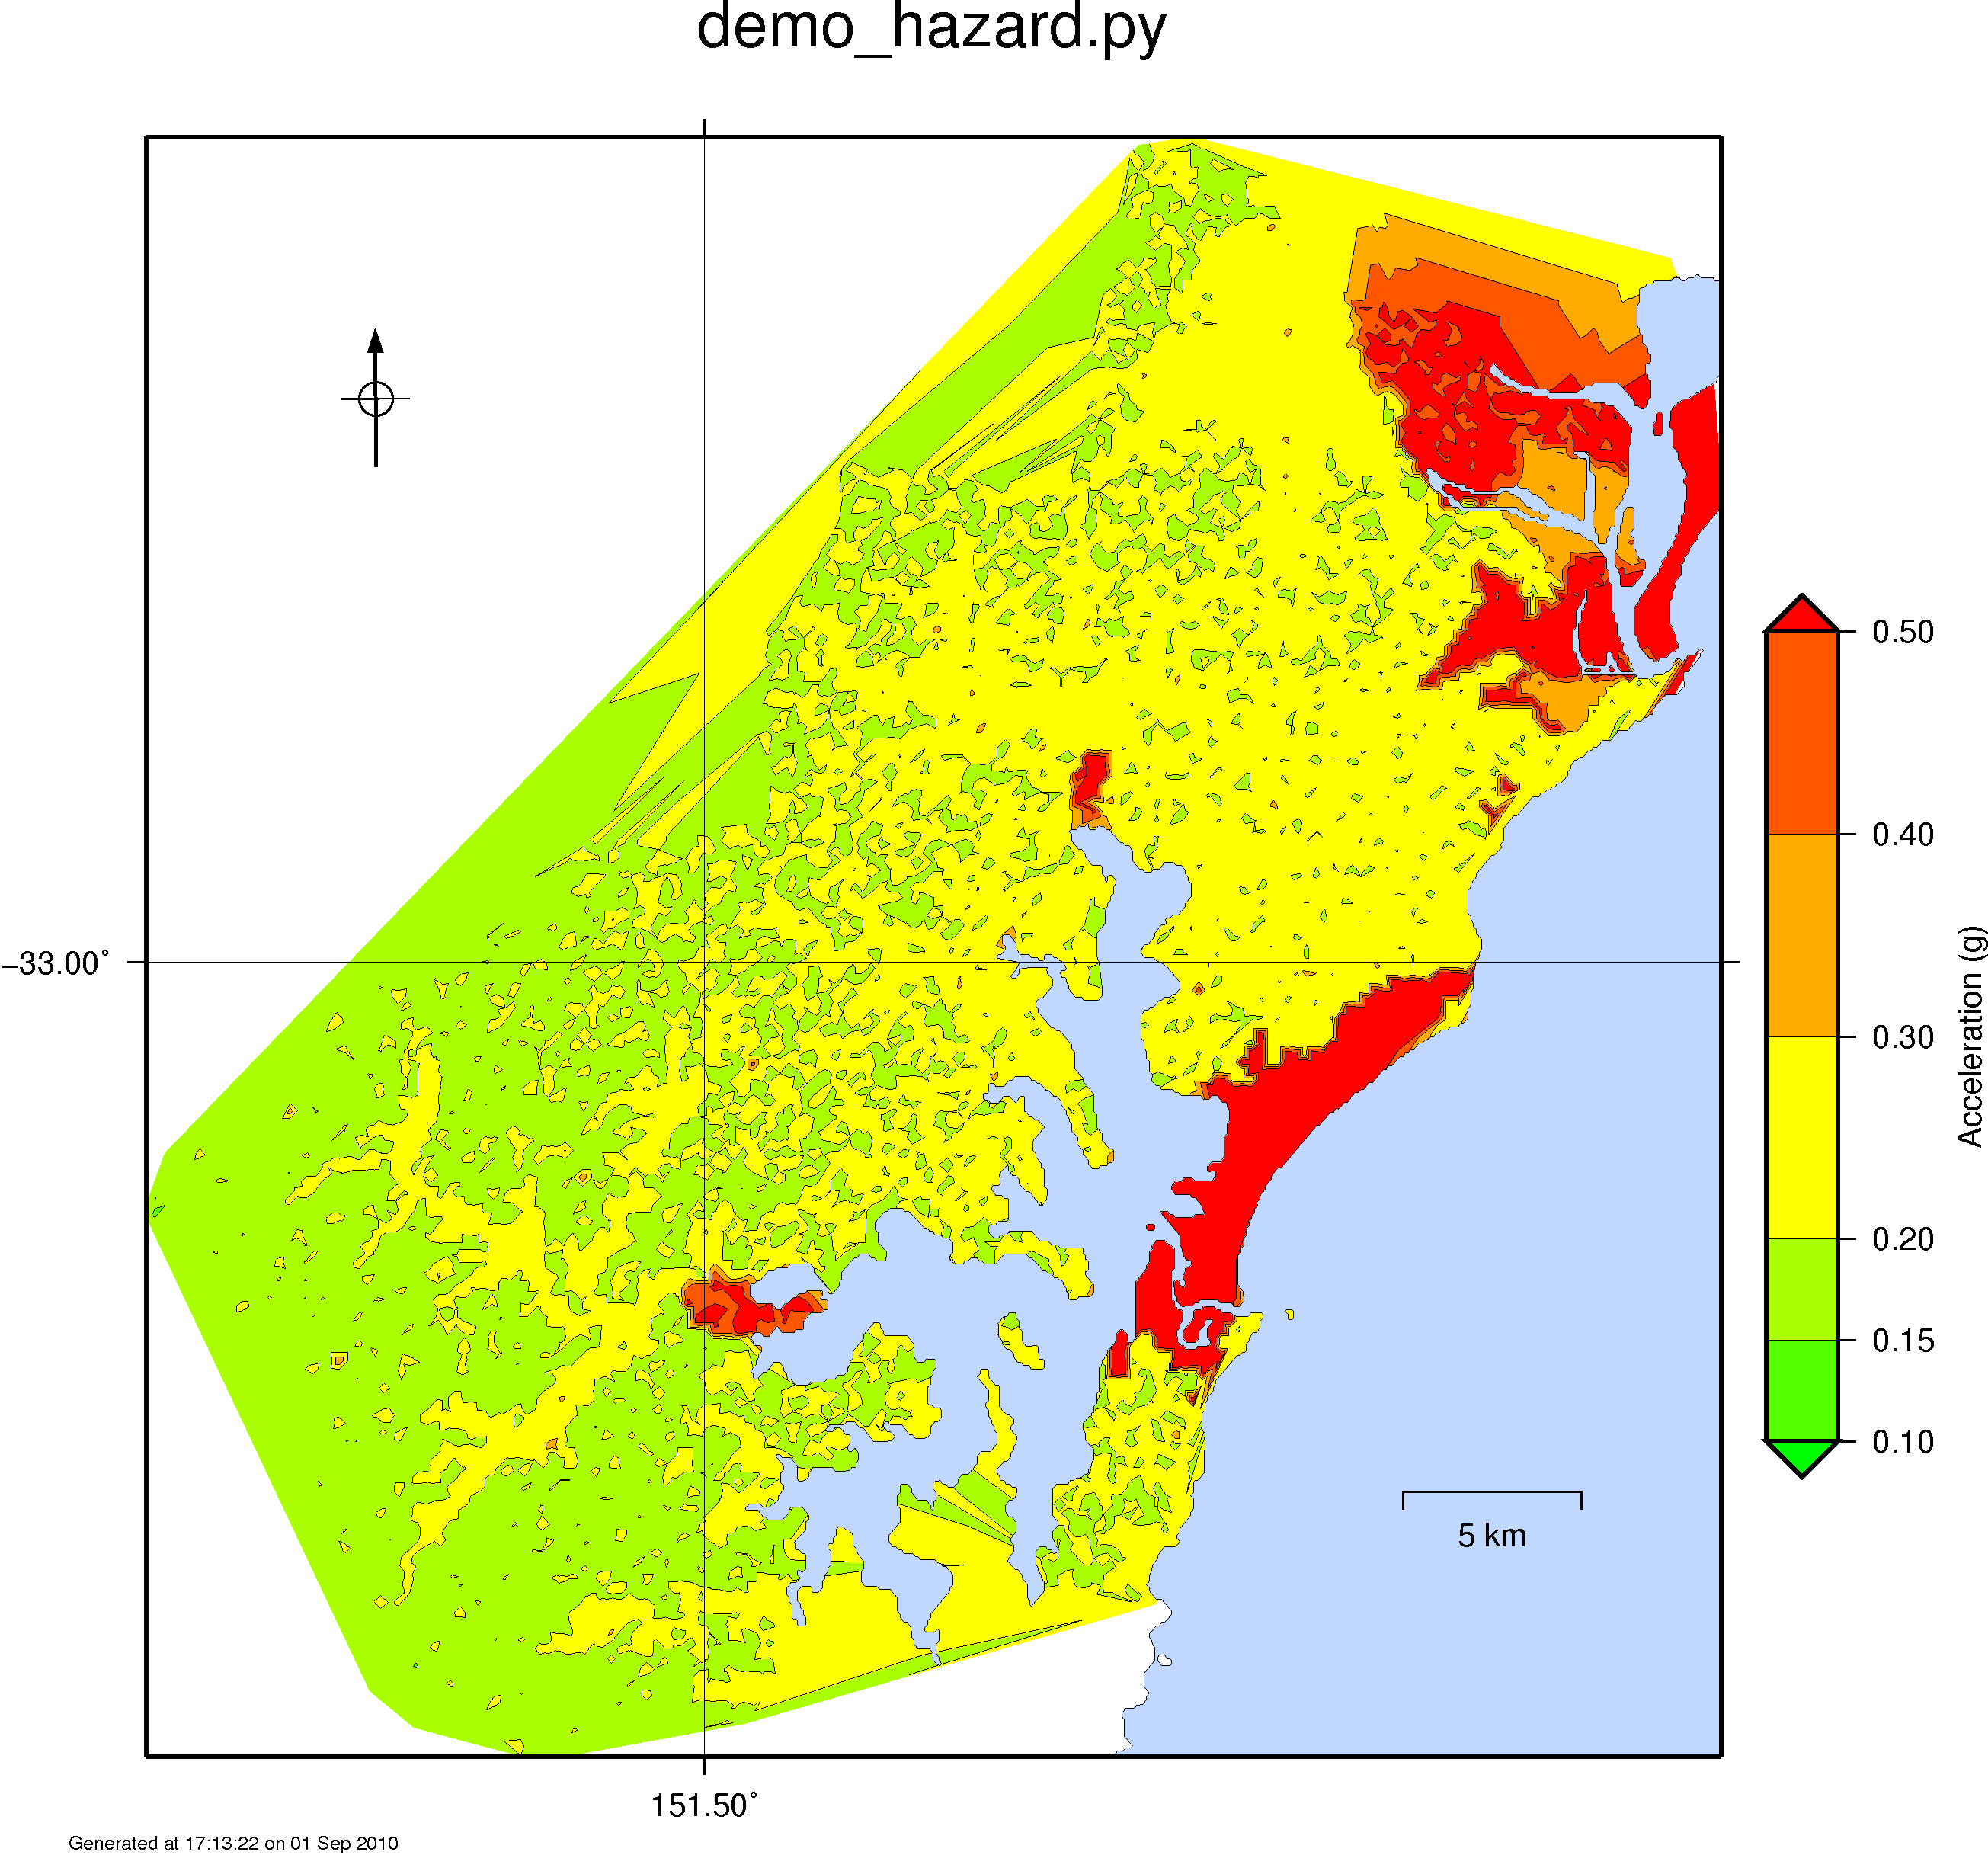

loss_exceedance
The simulation must be risk, probabilistic.
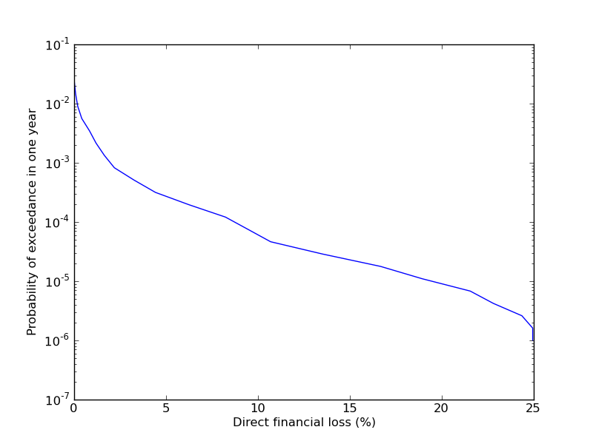

annloss_deagg_distmag
The simulation must be risk, probabilistic.
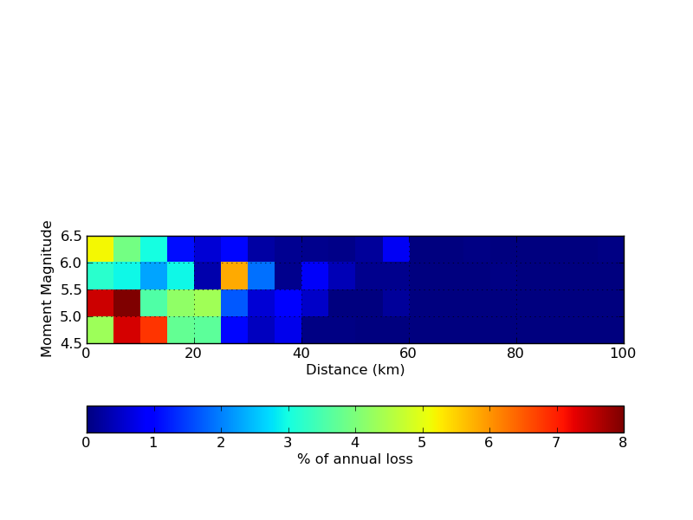

annloss_deagg_cells
The simulation must be risk, probabilistic.
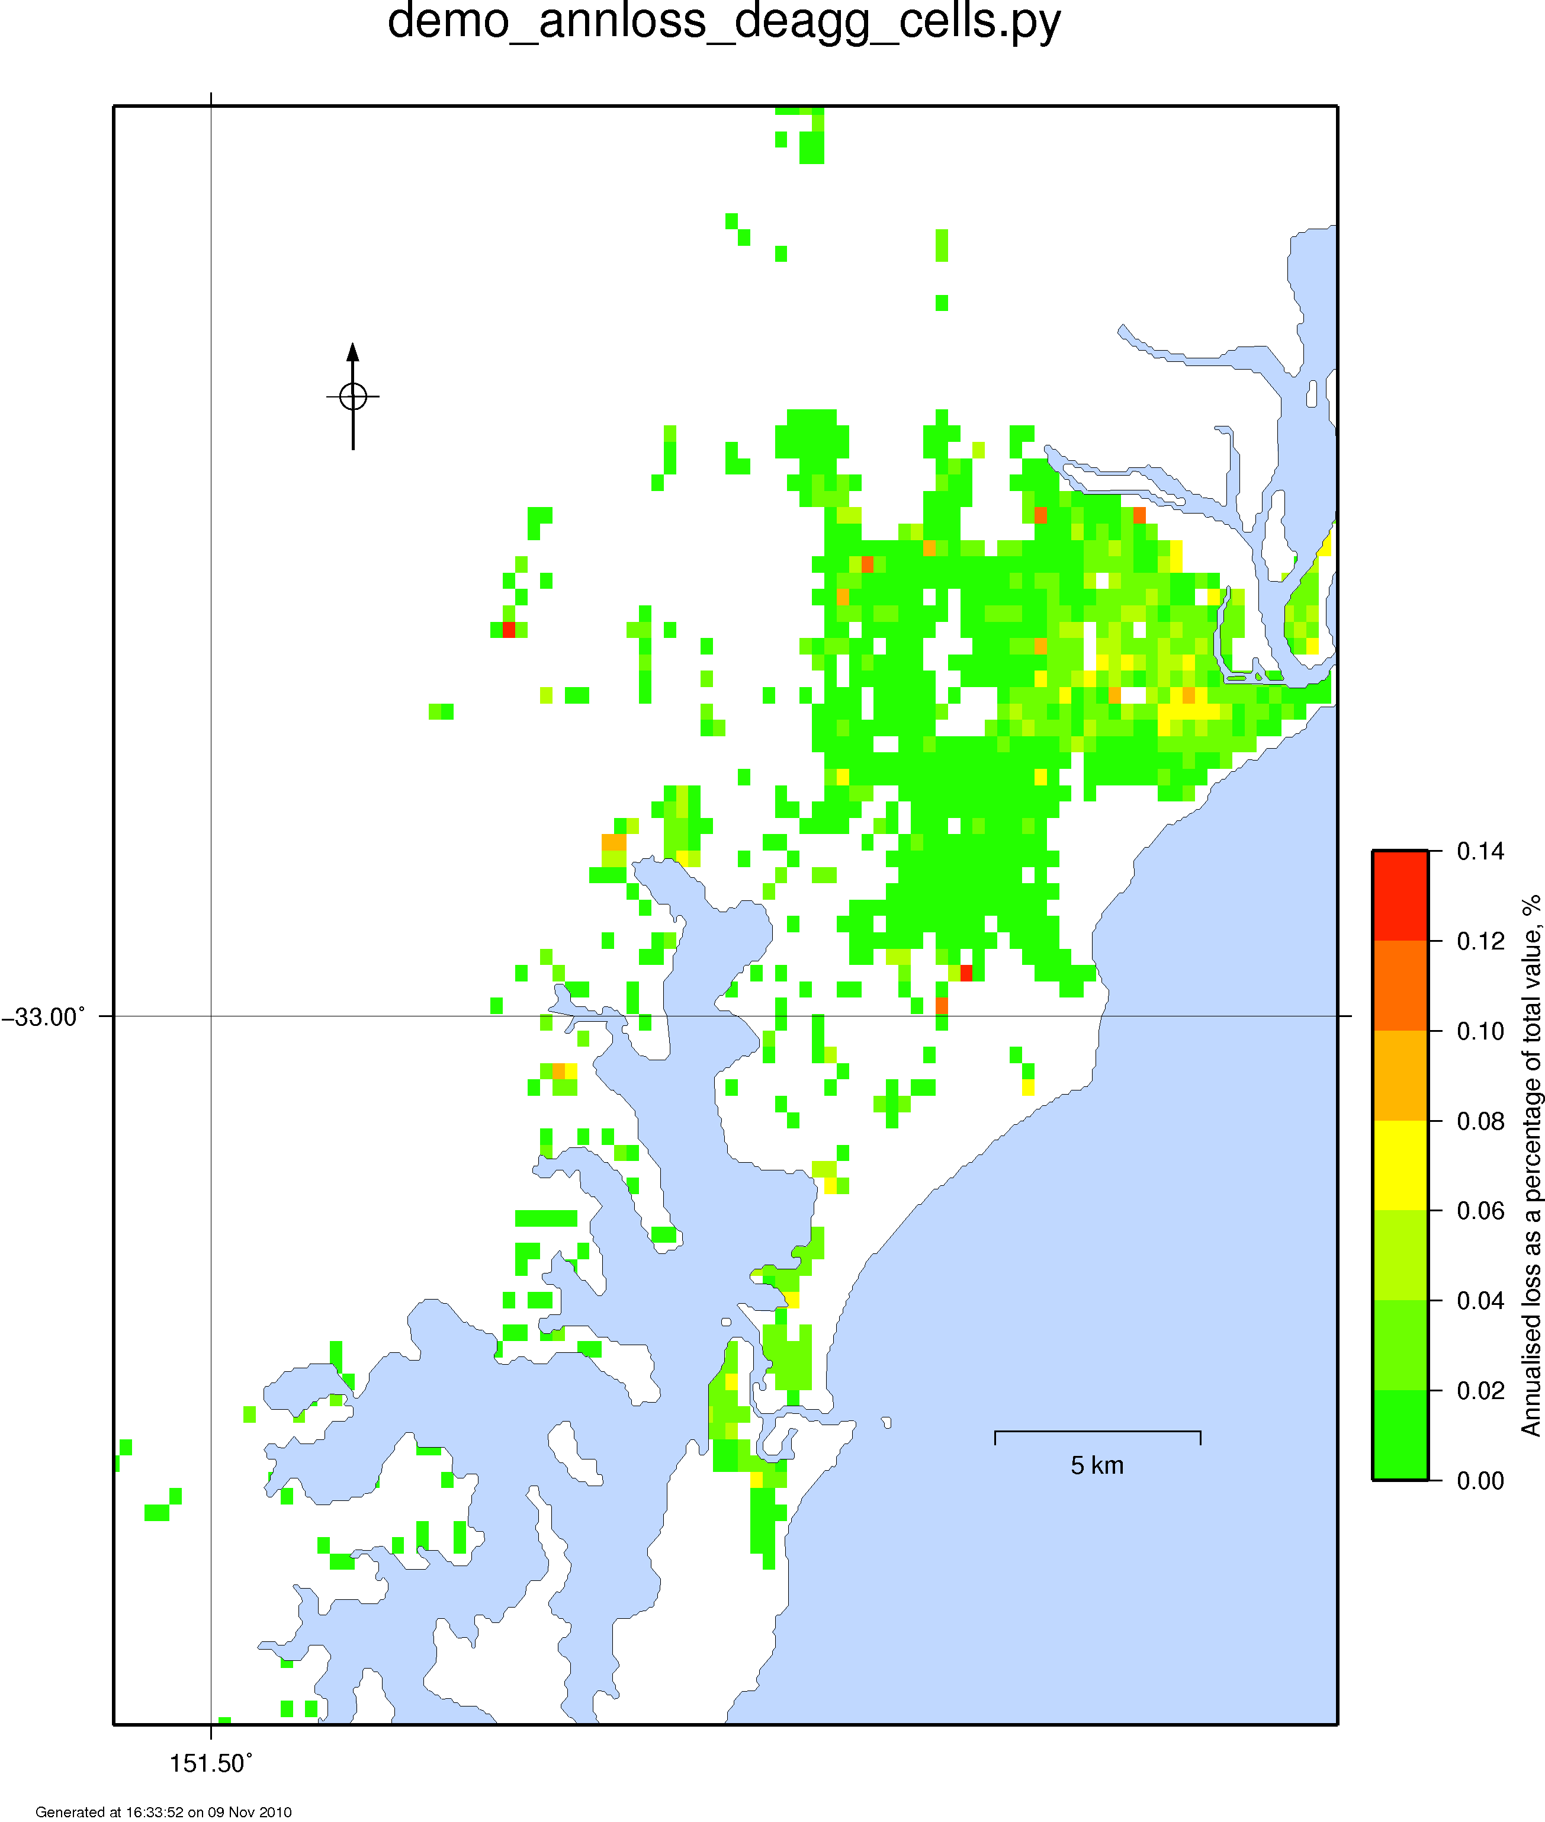

Histogram
The simulation must be probabilistic.

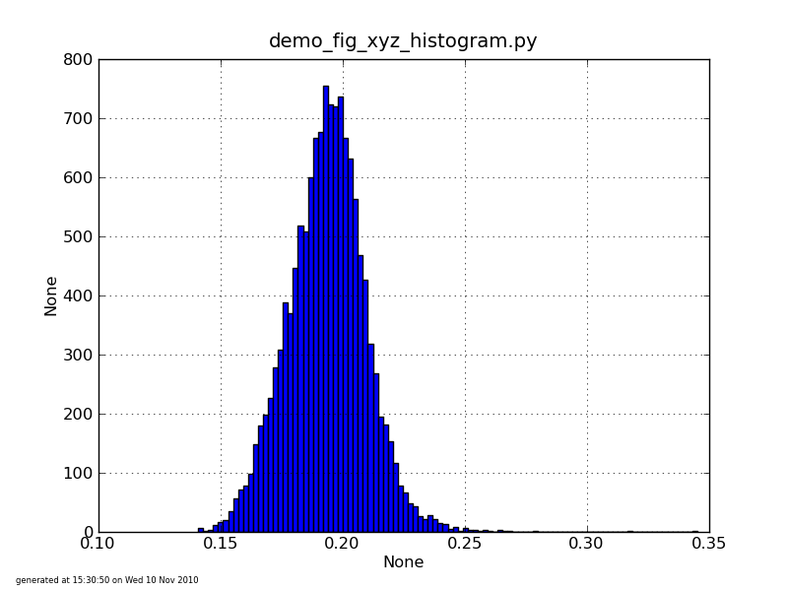

To be done

annloss_deagg_structural
The simulation must be risk, probabilistic.

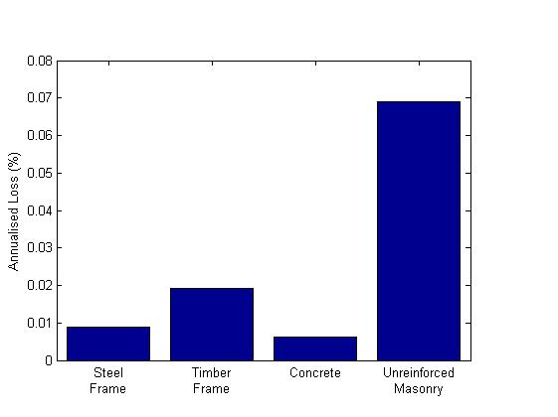
Calculate the annualised loss for each structure grouping. Normalise this into a percentage.

annloss
The simulation must be risk, probabilistic.

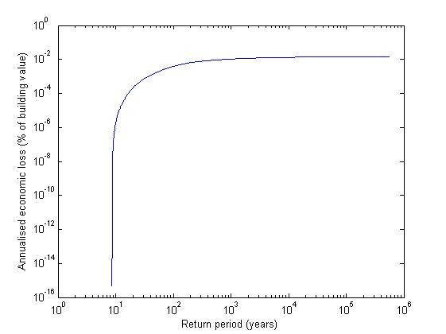
The data for this graph ‘falls out’, during the calculation of the overall annualised economic loss.

Sort the economic loss as a percentage of building value, from highest to lowest, across all locations and events. Get the return period from calculating the annual exceedance rate (fomula 9.4 in EQRM manual).

scen_loss_stats(_B)
The simulation must be risk, scenario. 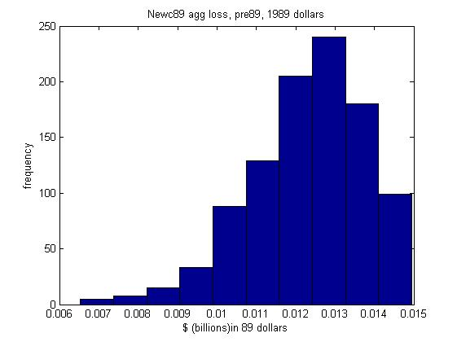
Sum loss of all structures for each event, and then bin the sum, for each event.
As a check summing all the frequency values together will give the number of events.
Use output_manager.load_ecloss_and_sites.;
Return:
total building loss with dimensions(location, event)
total building values with the dimension location
lon values with the dimension location
lat values with the dimension location

Sum on the site dimension, then bin.

scen_loss_stats_percentage
The simulation must be risk, scenario.

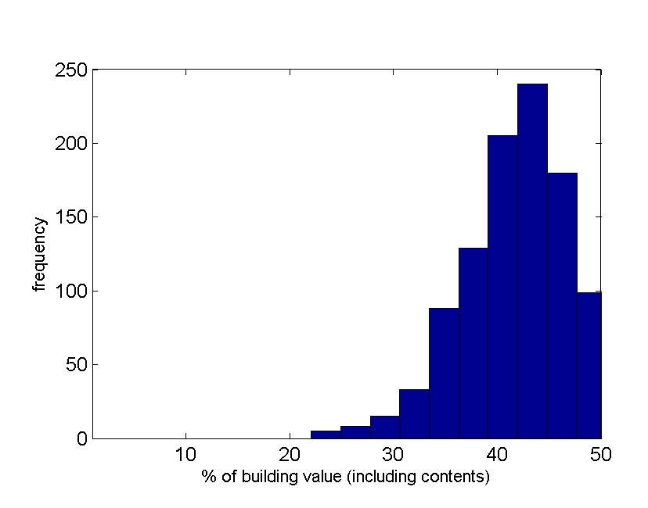
Bin the percentage of building value.
As a check summing all the frequency values together will give the number of events * number of structures.

Use output_manager.load_ecloss_and_sites.;
Return:
total building loss with dimensions(location, event)
total building values with the dimension location
lon values with the dimension location
lat values with the dimension location

Sum on the site dimension, for total building loss. Sum the total building values. Calc % of building value with dimension event. Bin.

Hazard at locations and return periods.
The simulation must be risk, probabilistic.
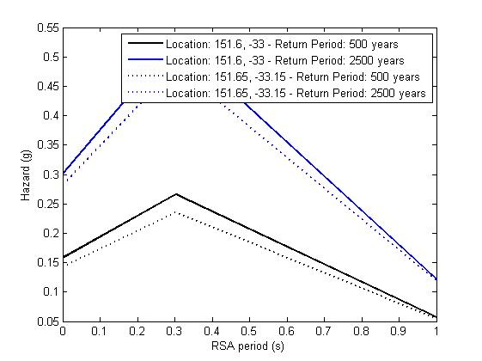
A different way of slicing the SA w.r.t. location, RSA period and return period cube.

Specify multiple location and return period tuples., Show the SA vs RSA period graph.

Use output_manager.load_hazards to get the SA w.r.t. site, periods and return period.
Use load_sites to get the lat and long.

Test with demo_hazard_sites.py

Hazard exceedance curve
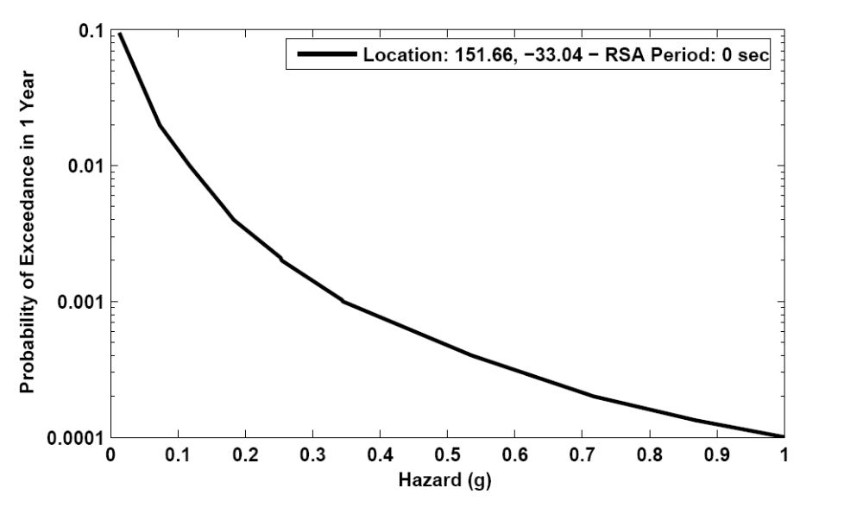
Slice the SA w.r.t. location, RSA period and return period cube.

Specify multiple location and return period tuples. Show the probability of exceedance (1/return period) vs RSA period graph.

Use output_manager.load_hazards to get the SA w.r.t. site, periods and return period.
Use load_sites to get the lat and long.

scenario % loss map

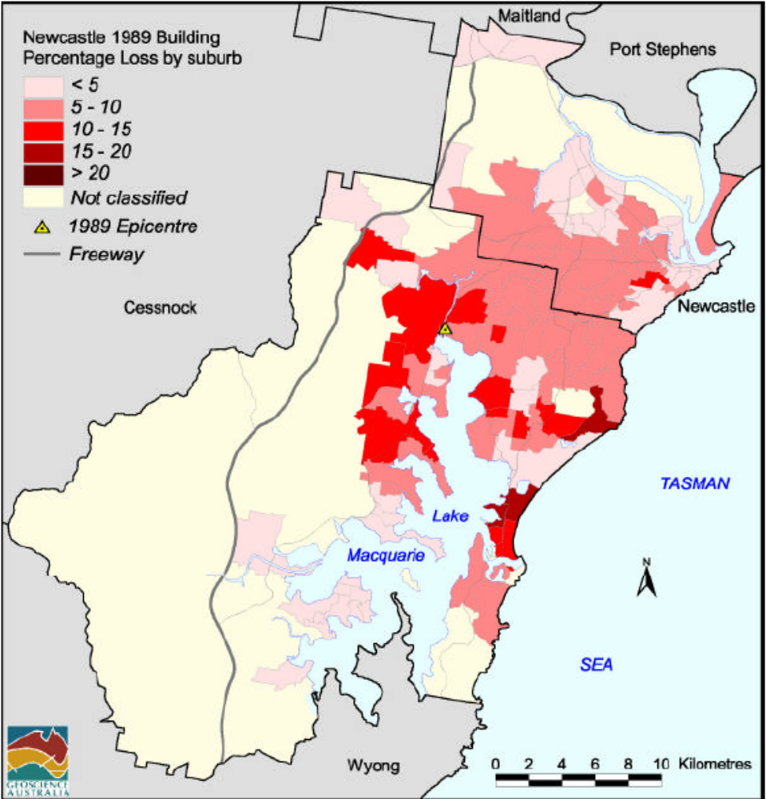
(example is fig 6.5 Newcastle report.).
Do not do it by suburb, use cells.
Sum the loss for each location, w.r.t. cell and event. Result is summed loss with dimensions (cell, event)
Sum the total building value for each location, w.r.t. cell and event. Result is summed total building value with dimensions (cell, event).

Now the % loss for each cell, for each event can be calculated. Result is % loss with dimensions (cell, event).

Now statistical methods can be used to collapse out the /event dimension.
Let the user choose if the output is the mean, median or sigma % loss per cell.

Use the \demo\output\scen_risk data to produce an example of this. newc_total_building_loss.txt has building loss w.r.t. site and event.
newc_structures.txt will have the lats and longs of the sites.
newc_bval.txt has building value per site.

The Matlab postprocessing tools do not produce scenario loss maps. See the manual, page 113 for more info on scenario results.

Scenario motion

This will look like a probabilistic hazard map, though there will be no return period. Let the user choose if the SA values used will be mean or median values, with respect to multiple events at the same location. Let’s not worry about weighting these results to take into account splitting initially.

Use output_manager. load_motion_sites
Returns:
SA: Array of spectral acceleration
dimensions (sites, events*gmm*spawn)
lat: a vector of latitude values, site long
lon: a vector of longitude values, site long

